Name:
Certification:
Date:

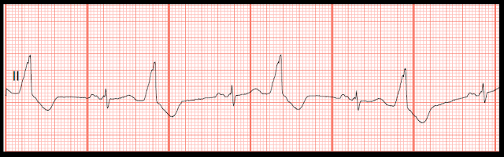
a. Ventricular tachycardia
b. Sinus rhythm with multifocal PVCs
c. Sinus rhythm with a couplet of PVCs
d. Sinus rhythm with bigeminal PVCs
e. Agonal rhythm
02 Identify the following rhythm.
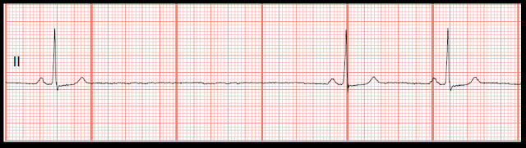
a. Asystole
b. Sinus arrest
c. Sinus arrhythmia
d. Sinus rhythm with a dropped PAC
e. Junctional rhythm
03 Identify the following rhythm.
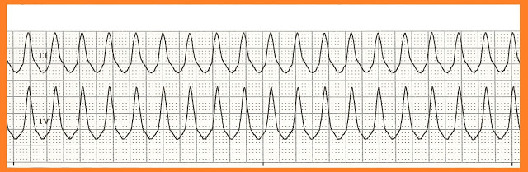
a. Supraventricular tachycardia
b. Sinus tachycardia
c. Multifocal atrial tachycardia
d. Atrial tachycardia
e. Ventricular tachycardia
04 Identify the following rhythm.
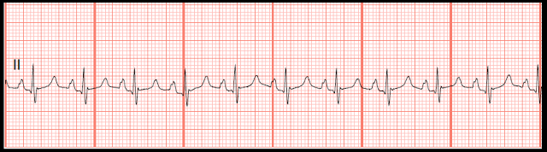
a. Sinus tachycardia
b. Ventricular tachycardia
c. Multifocal atrial tachycardia
d. Junctional tachycardia
e. Atrial fibrillation with rapid ventricular response
05 Identify the following rhythm.
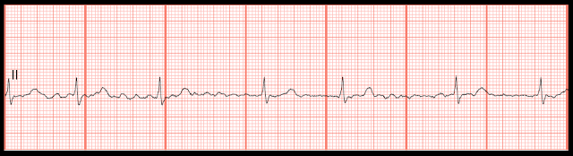
a. Sinus arrhythmia
b. Sinus rhythm with PACs
c. Atrial fibrillation
d. Sinus rhythm with PJCs
e. Atrial flutter
06 Identify the following rhythm.
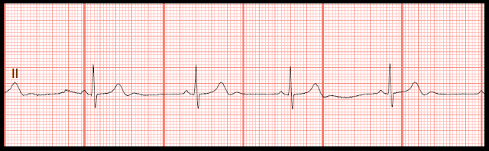
a. Junctional rhythm
b. Sinus bradycardia
c. Atrial fibrillation with slow ventricular response
d. Idioventricular rhythm
e. Sinus rhythm with pauses
07 Identify the following rhythm.
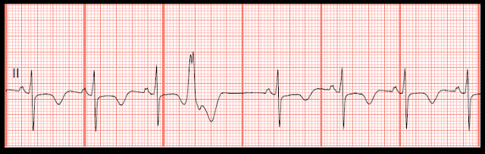
a. Sinus rhythm with a PVC
b. Sinus rhythm with a PJC
c. Sinus rhythm with a PAC
d. Sinus rhythm with a dropped PAC
e. Sinus rhythm with a couplet
08 Identify the following rhythm.
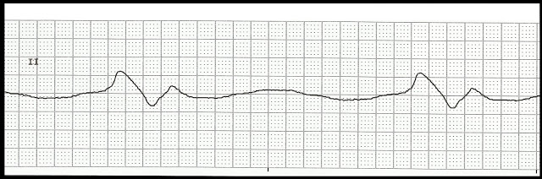
a. Asystole
b. Sinus arrest
c. Ventricular standstill
d. Agonal rhythm
e. Junctional rhythm
09 Identify the following rhythm.
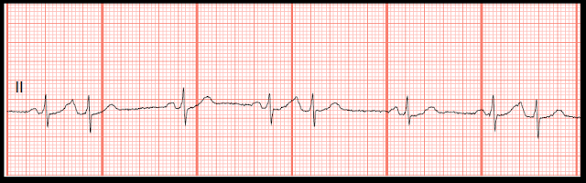
a. Sinus arrhythmia
b. Sinus rhythm with trigeminal PACs
c. Sinus rhythm with trigeminal PJCs
d. Sinus rhythm with trigeminal PVCs
e. Sinus rhythm with multifocal PVCs
10 Identify the following rhythm.
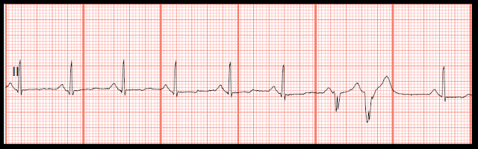
a. Sinus rhythm with unifocal PVCs
b. Sinus rhythm with multifocal PVCs
c. Sinus rhythm with bigeminal PVCs
d. Sinus rhythm with a couplet of PVCs
e. Sinus rhythm with a burst of VT
11 Identify the following rhythm.
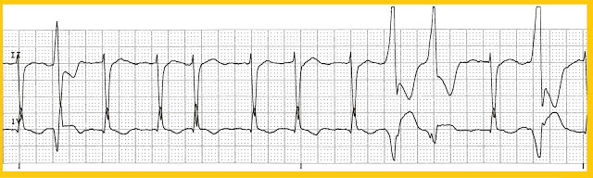
a. Sinus rhythm with multiple PVCs
b. Sinus arrhythmia with multiple PVCs
c. Atrial fibrillation with multiple PVCs
d. Wandering atrial pacemaker with multiple PVCs
e. Sinus tachycardia with multiple PVCs
12 Identify the following rhythm.
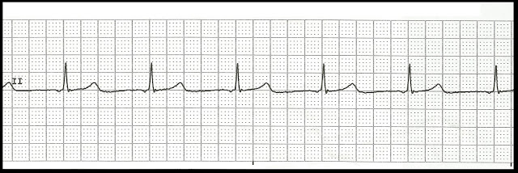
a. Normal sinus rhythm
b. Sinus bradycardia
c. Idioventricular rhythm
d. Atrial fibrillation
e. Junctional rhythm
13 Identify the following rhythm.
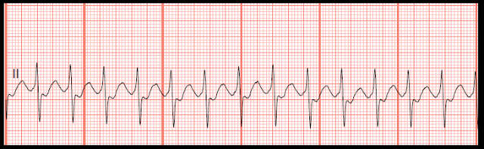
a. Supraventricular tachycardia
b. Ventricular tachycardia
c. Multifocal atrial tachycardia
d. Atrial tachycardia
e. Sinus tachycardia
14 Identify the following rhythm.
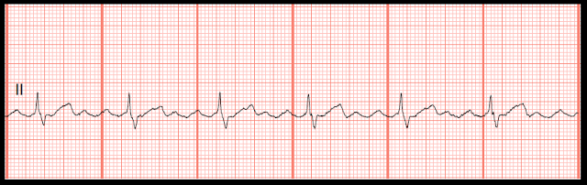
a. Atrial fibrillation
b. Atrial tachycardia
c. Atrial flutter
d. Wandering atrial pacemaker
e. Junctional rhythm
15 Identify the following rhythm.
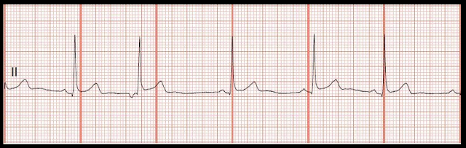
a. Sinus rhythm with a PAC
b. Sinus bradycardia with a PJC
c. Sinus bradycardia with PVC
d. Sinus rhythm with a PJC
e. Sinus bradycardia with a PAC
16 Identify the following rhythm.
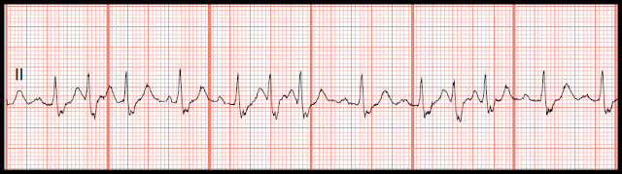
a. Wandering atrial pacemaker
b. Multifocal atrial tachycardia
c. Atrial fibrillation with rapid ventricular response
d. Atrial flutter with rapid ventricular response
e. Supraventricular tachycardia
17 Identify the following rhythm.
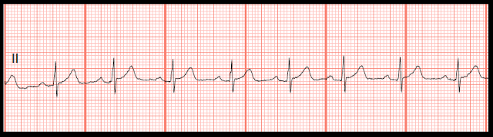
a. Normal sinus rhythm
b. Sinus bradycardia
c. Junctional rhythm
d. Accelerated junctional rhythm
e. Atrial fibrillation
18 Identify the following rhythm.
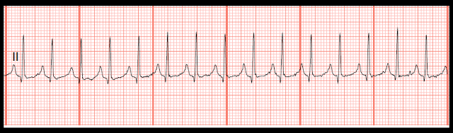
a. Atrial tachycardia
b. Junctional tachycardia
c. Sinus tachycardia
d. Supraventricular tachycardia
e. Multifocal atrial tachycardia
19 Identify the following rhythm.
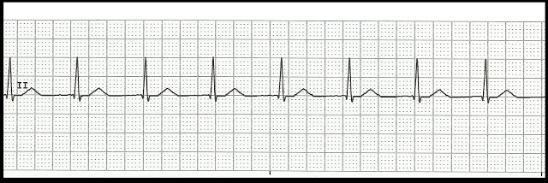
a. Accelerated idioventricular rhythm
b. Atrial fibrillation with a controlled rate
c. Accelerated junctional rhythm
d. Normal sinus rhythm
e. Ventricular fibrillation
20 Identify the following rhythm.
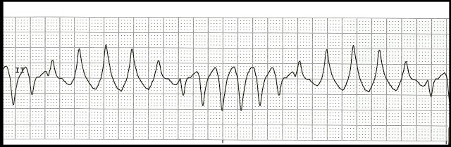
a. Ventricular tachycardia
b. Atrial fibrillation
c. Ventricular fibrillation
d. Polymorphic ventricular tachycardia
e. Torsades de pointes
21 Identify the following rhythm.
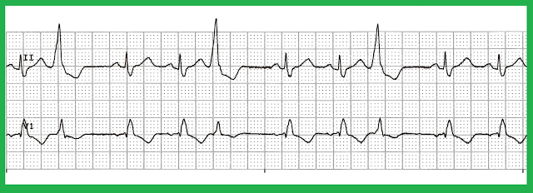
a. Sinus rhythm with multifocal PVCs
b. Sinus rhythm with trigeminal PVCs
c. Sinus rhythm with unifocal PVCs
d. Sinus rhythm with multiple PACs
e. Sinus rhythm with a triplet of PVCs
22 Identify the following rhythm.
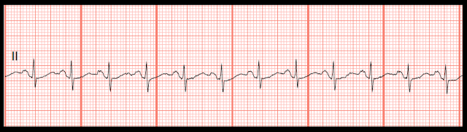
a. Sinus tachycardia
b. Junctional tachycardia
c. Ventricular tachycardia
d. Supraventricular tachycardia
e. Multifocal atrial tachycardia
23 Identify the following rhythm.
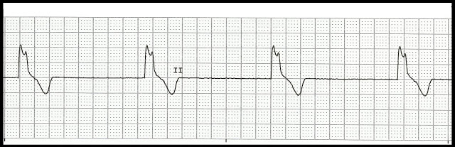
a. Junctional rhythm
b. Ventricular tachycardia
c. Sinus rhythm with pauses
d. Idioventricular rhythm
e. Atrial fibrillation with slow ventricular response
24 Identify the following rhythm.
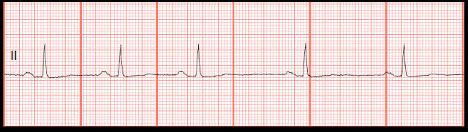
a. Sinus rhythm with pauses
b. Sinus bradycardia with sinus arrest
c. Atrial fibrillation with slow ventricular response
d. Junctional rhythm
e. Sinus bradycardia with sinus arrhythmia
25 Identify the following rhythm.
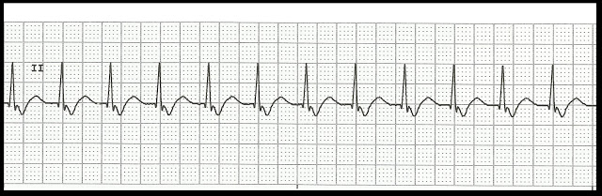
a. Sinus tachycardia
b. Junctional tachycardia
c. Atrial tachycardia
d. Supraventricular tachycardia
e. Ventricular tachycardia

Practice Strips Answers

01. d. Sinus rhythm with bigeminal PVCs
02. b. Sinus arrest
03. e. Ventricular tachycardia
04. a. Sinus tachycardia
05. c. Atrial fibrillation
06. b. Sinus bradycardia
07. a. Sinus rhythm with a PVC
08. d. Agonal rhythm
09. b. Sinus rhythm with trigeminal PACs
10. d. Sinus rhythm with couplet of PVCs
11. c. Atrial fibrillation with multiple PVCs
12. e. Junctional rhythm
13. a. Supraventricular tachycardia
14. c. Atrial flutter
15. b. Sinus bradycardia with a PJC
16. b. Multifocal atrial tachycardia
17. a. Normal sinus rhythm
18. d. Supraventricular tachycardia
19. c. Accelerated junctional rhythm
20. e. Torsades de pointes
21. b. Sinus rhythm with trigeminal PVCs
22. a. Sinus tachycardia
23. d. Idioventricular rhythm
24. e. Sinus bradycardia with sinus arrhythmia
25. b. Junctional tachycardia

